
Company
Logotype

Cone Beam Computed Tomography- Report



Porur Dental X-rays & CBCT

Patient Name : Mrs. Sravani | Date of Report : 19.05.2025
Age/ Gender : 36 years/ Female | Region of Interest : CBCT Sectional Mandible
Referring doctor: Dr. Selva Ganesh | Indication : Assessment of 36
Clinical Notes: Nil
PATIENT INFORMATION

CBCT- Sectional Mandible provided
CBCT – IMAGE DETAILS

RADIOGRAPHIC INTERPRETATION

- In relation to 36 presence of hyperdense restorative material involving the crown, extending into the mesio- buccal, mesio-lingual and distal canals upto the apical portion of the root. In relation to the periapical aspect of the distal root, there is evidence of a diffuse irregular hypodense area, measuring 3.75 x 3.03 x 3.13 mm in dimension. Additionally, there is an accessory canal evident in the distal root, anterior to the existing restorative material.
- In relation to 35, presence of a hyperdense structure evident in the pulp canal, measuring
- There is no visible fracture line present in relation to 45 and 46.

RADIOGRAPHIC IMPRESSION

- Impacted tooth : 48

Kindly correlate with clinical findings


IMAGES FOR REFERENCE

Reconstructed Panoramic view
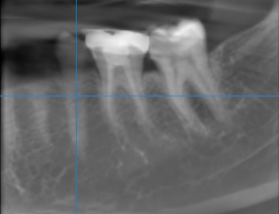

Multiplanar reconstruction view
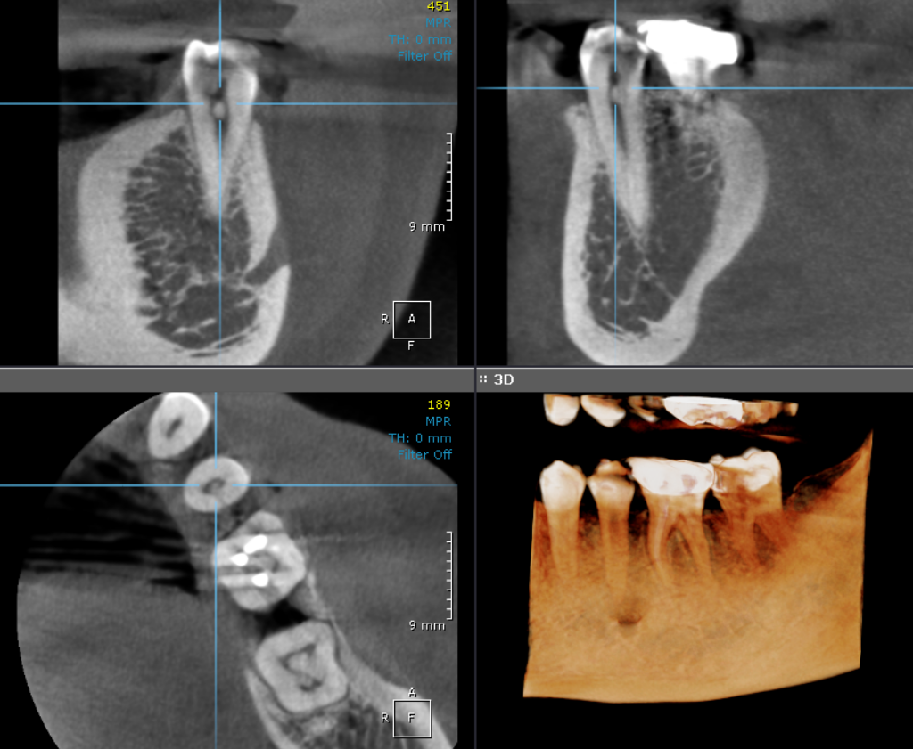

3-DIMENSIONAL VIEW
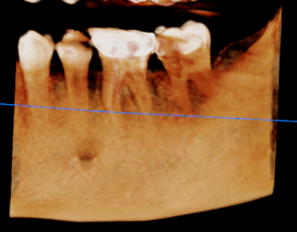

CROSS SECTIONAL VIEW OF 35

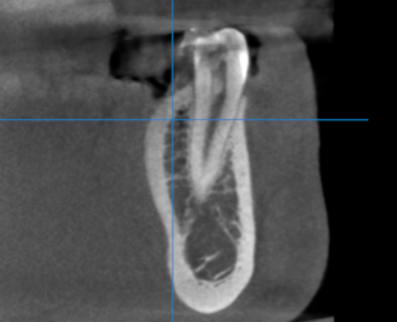

CROSS SECTIONAL VIEW OF 36

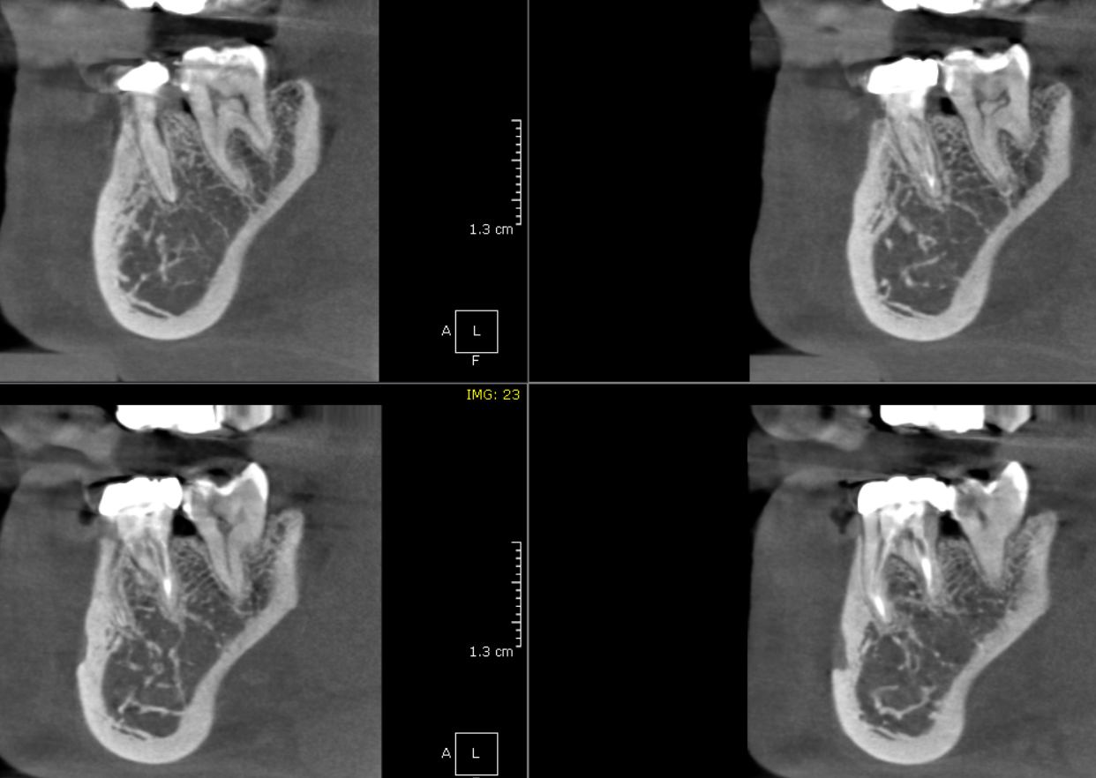

**** End of report ****

